Names of Group Members: _______________________________________________________________________
Period ______
Mapping and Annotating American Imperialism
In this assignment you will learn concepts and events of late 19th and early 20th century American imperialism, by creating an annotated map. For each item, you will succinctly identify the significance and neatly write the significance in the appropriate location on the map. Your annotation should reflect the most important ways in which the event demonstrates how the United States is an actor within the context of world history.
A sample annotation has been completed for the Alaska Purchase.

- Alaska Purchase
- Alfred Thayer Mahan
- Acquisition of Hawaii
- Acquisition of Samoa
- Open Door Policy-
- Boxer Rebellion-
- The Explosion of the Maine/ Yellow Journalism
- The Spanish American War
- The Anti-Imperialist League
- The Teller Amendment
- The Platt Amendment
- Acquisition of Guam
- Filipino Insurrection
- Acquisition of Puerto Rico / Insular Cases
- Roosevelt Corollary
- Dollar Diplomacy
- Moral Diplomacy / Pancho Villa

Choose 7 of the following questions to answer with historical detail in at least 3 well-developed sentences:
1. Why would some in the United States begin to look overseas and advocate territorial expansion in the late 19th century?
2. Geographically describe the locations of US territorial acquisitions. What might have contributed to these patterns?
3. How is military might and power linked to economic success?
4. Identify three arguments for imperialism. Which do you believe was the most justifiable? The least?
5. Identify three arguments against imperialism. Which resonates with you the most?
6. Why would some in the United States begin to look overseas and advocate territorial expansion in the late 19th century?
7. Geographically describe the locations of US territorial acquisitions. What might have contributed to these patterns?
8. What contextual information can help us understand why the United States was considered a reluctant imperial power?
9. What social theories or trends may have contributed to US imperial ambitions?
10. How is military might and power linked to economic success?
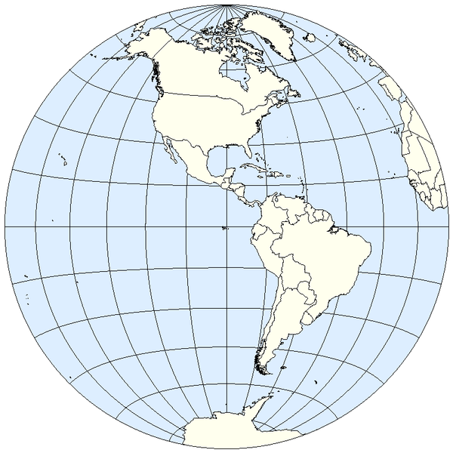
Alaska Purchase- known as “Seward’s Folly”, bought from Russia in 1867. Although some criticized it as worthless, many viewed it as strengthening US commercial trade expansion in the Pacific and weakening Britain’s position.

