Name: ________________________________________
Gilded Age Immigration Political Cartoon Analysis
Image A: 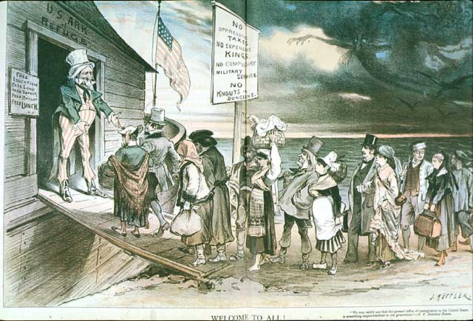
Image from Keppler, Puck Magazine, April 28, 1880

Image B:
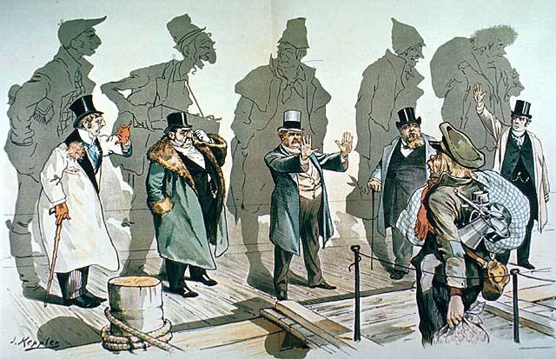
Image from Keppler, Puck Magazine, January 11, 1893

Gilded Age Political Cartoon Analysis (Last stop!)
Directions:
As you examine the political cartoons on the front table, answer the following questions with care and historical detail.
Image A
- When was this cartoon published? ______________________________________________________________
- Because I observe this: ___________________________________________________________________________________________, I can conclude this: ___________________________________________________________________________________________

___________________________________________________________________________________________.
- Because I observe this: ___________________________________________________________________________________________, I can conclude this: ___________________________________________________________________________________________

___________________________________________________________________________________________.

- The overall message toward immigrants in Image A is:

Image B
- When was this cartoon published? ______________________________________________________________
- Because I observe this: ___________________________________________________________________________________________, I can conclude this: ___________________________________________________________________________________________

___________________________________________________________________________________________.
- Because I observe this: ___________________________________________________________________________________________, I can conclude this: ___________________________________________________________________________________________

___________________________________________________________________________________________.

- The overall message toward immigrants in Image B is:

- Based on what we have studied in class and your observations, what accounts for the difference in the two cartoons? In other words, why would the message towards immigrants change over time? Use historical detail in your answer.

