Gilded Age Inquiry
Is Greed Good?
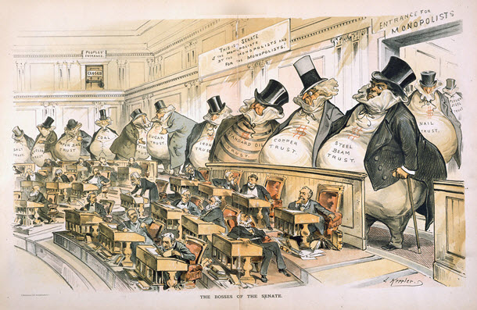
Public domain. J. Ottmann Lith. Co. after Joseph Keppler, The Bosses of the Senate, by Puck, January 23, 1889.

Supporting Questions
- What were some of the political, social, and economic conditions driving industrial growth from 1870 to 1900 in the United States?

- What were the positive aspects of industrialization in the Gilded Age?

- What were the negative aspects of industrialization in the Gilded Age?

Gilded Age Inquiry

Is Greed Good?
New York State Social Studies Framework Key Idea & Practices | 8.2 A CHANGING SOCIETY: Industrialization and immigration contributed to the urbanization of America. Problems resulting from these changes sparked the Progressive movement and increased calls for reform.  Gathering, Using, and Interpreting Evidence Comparison and Contextualization
Staging the Question | Discuss examples from everyday life when greed is good and times when greed is bad.

Supporting Question 1 |  | Supporting Question 2 |  | Supporting Question 3
What were some of the political, social, and economic conditions driving industrial growth from 1870 to 1900 in the United States? |  | What were the positive aspects of industrialization in the Gilded Age? |  | What were the negative aspects of industrialization in the Gilded Age?
Formative  Performance Task |  | Formative  Performance Task |  | Formative  Performance Task
List the political, social, and economic conditions that drove industrial growth from 1870 to 1900 in the United States. |  | Create a political cartoon depicting and explaining the positive aspects of Gilded Age industrialists. |  | Add to the political cartoon with information depicting and explaining the negative aspects of Gilded Age industrialists.
Featured Sources |  | Featured Sources |  | Featured Sources
Source A: United States patent and invention activity in the 19th century  Source B: Map bank: United States railroads, 1860 and 1890  Source C: Graph of total immigration from 1820 to present  Source D: Illustration, The Bosses of the Senate |  | Source A: Graphs of oil prices and GNP  Source B: Excerpts from Senator Leland Stanford interview  Source C: Excerpts from “Wealth”  Source D: Cartoon, Carnegie Will Lay the Cornerstones Today |  | Source A: The Forty T----s [i.e. thieves]: Baba Jonathon: I don’t like your looks, Mr. Merchant, you had better move on  Source B: Excerpt from “Workingman’s Prayer for the Masses”  Source C: Editorial, “Evolution of the Robber Baron”  Source D: Excerpts from Theodore Roosevelt’s 1906 special message to Congress

Summative Performance Task | ARGUMENT Is greed good? Construct an argument (e.g., detailed outline, poster, essay) that evaluates whether or not mostly unregulated capitalism was beneficial to the United States during the Industrial Age.
 | EXTENSION Write a campaign speech favoring or opposing a pro-corporation candidate running for president at the turn of the century.
Taking Informed Action | UNDERSTAND Explore the present-day issue of income inequality related to regional, racial, gender, and/or socioeconomic factors in the United States.  ASSESS Determine the degree to which specific government actions (or inactions) would affect income inequality in the United States.  ACT Create a public service announcement that explains how local, state, and/or federal governments can best address the issue.

Supporting Question 1
Featured Source | Source A: United State Patent and Trademark Office, chart of patent and invention activity in the 19th century, U.S. Patent Activity Calendar Years 1790 to the Present; chart of notable American inventions, 2015

NOTE: Patent activity in the United States increased dramatically in the second half of 19th century into the early 20th century. From 1850 to 1910, the number of “Utility Patents” or patents for inventions increased many times over from 2,193 patent applications issued in 1850 to 63,293 applications in 1910.
The United States Patent and Trademark Office displays information on the annual US Patent Activity Since 1790 on its website at: http://www.uspto.gov/web/offices/ac/ido/oeip/taf/h_counts.htm.

Created for the New York State K–12 Social Studies Toolkit by Binghamton University, 2015.

Supporting Question 1
Featured Source | Source B: Map bank: United States railroads, 1860 and 1890

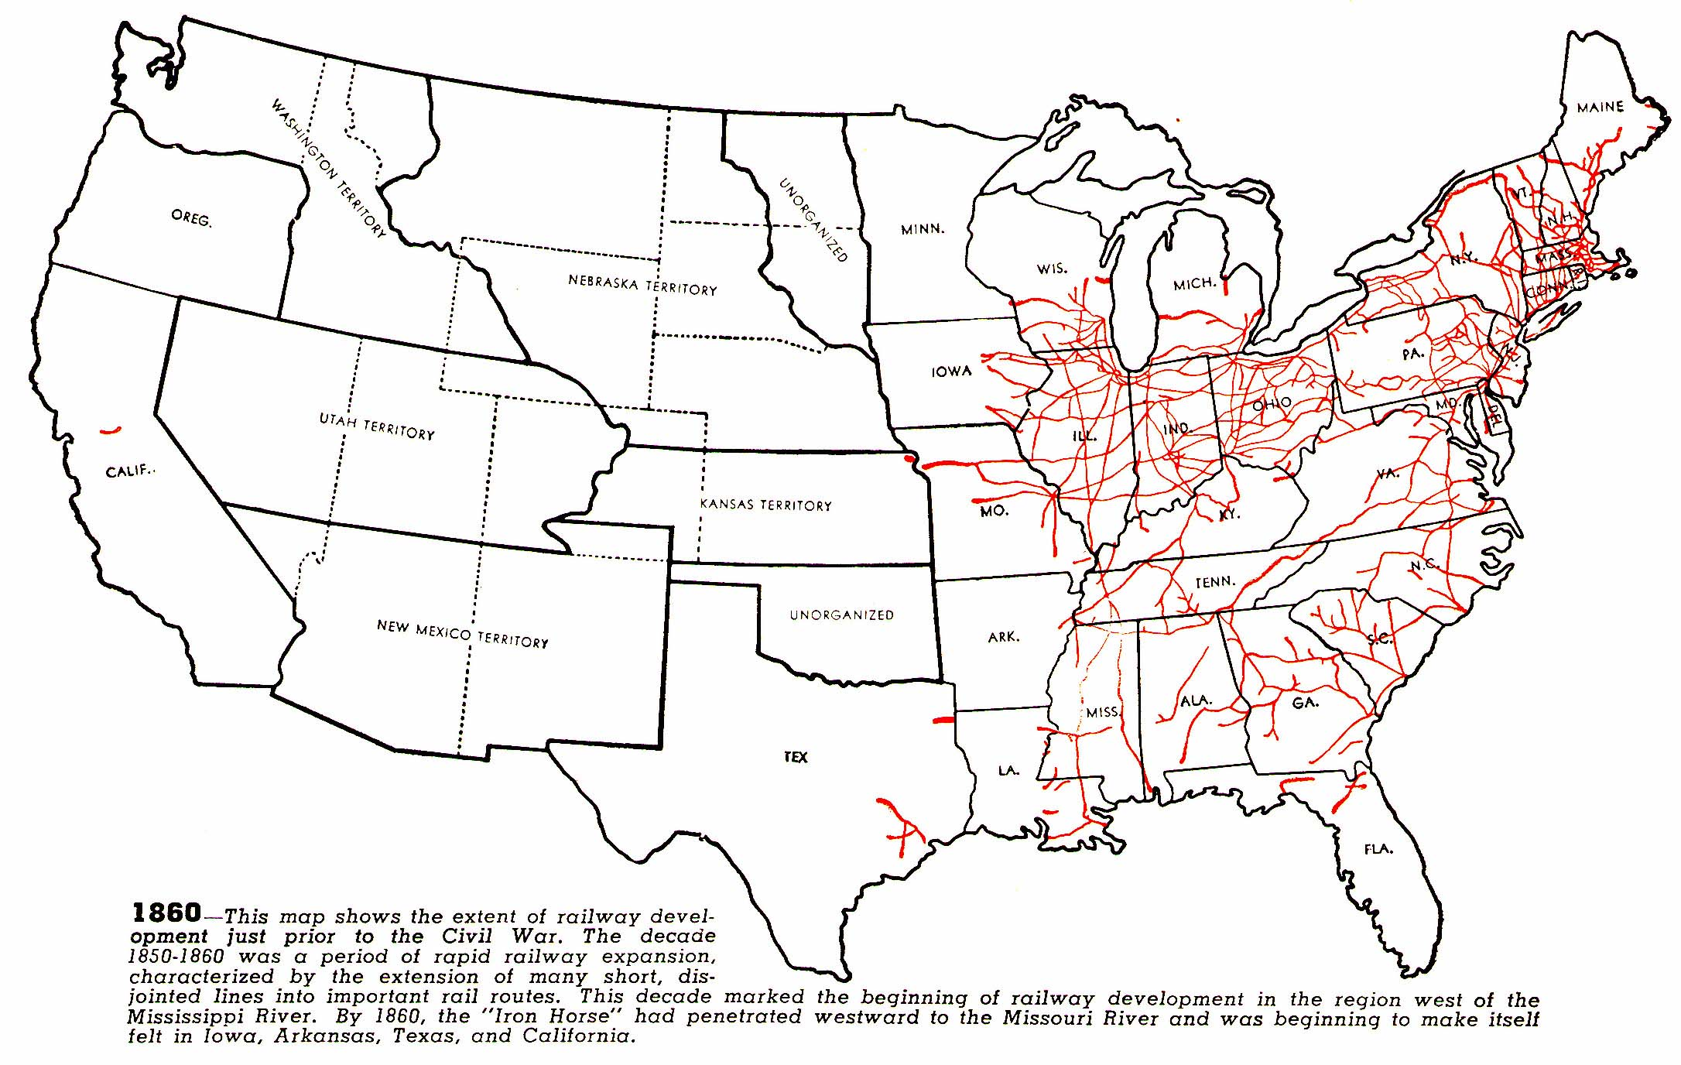
Map 1: Map of railroad in the United States in 1860.
Courtesy of Dr. Gayle Olson-Raymer, Humboldt State University.

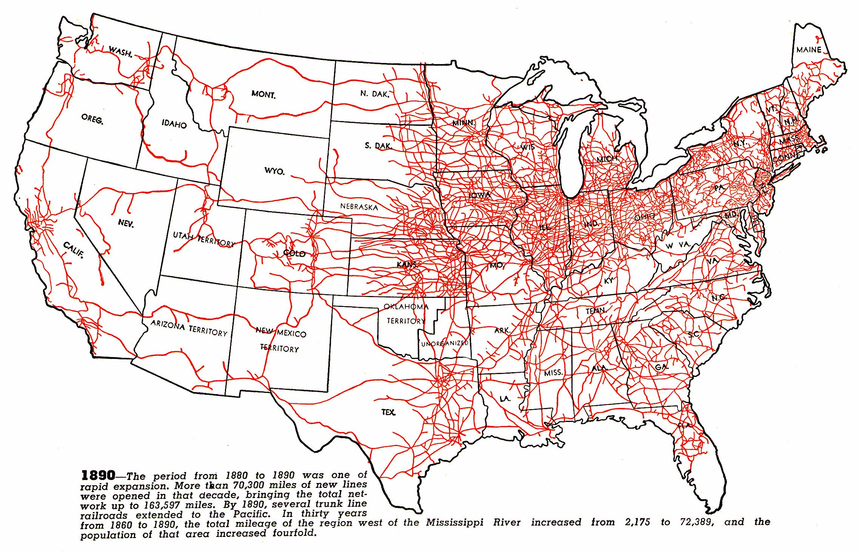
Map 2: Map of railroad in the United States in 1890.
Courtesy of Dr. Gayle Olson-Raymer, Humboldt State University.

Supporting Question 1
Featured Source | Source C: Scholastic, graph of United States immigration from 1820 to present, “Total Immigrants by Decade”

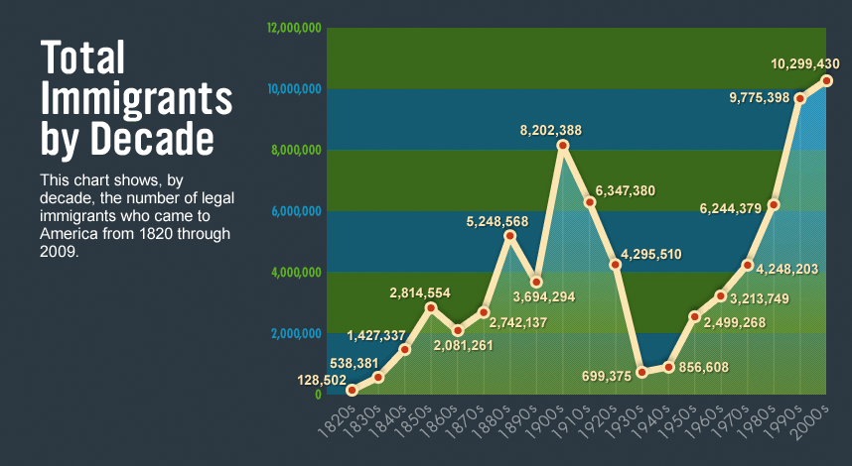

"Total Immigrants by Decade" graph from http://teacher.scholastic.com/activities/immigration/. Copyright © by Scholastic Inc. Used by permission.
Supporting Question 1
Featured Source | Source D: J. Ottmann Lith. Co. after Joseph Keppler, political cartoon depicting corruption in the United States Senate, The Bosses of the Senate, Puck, January 23, 1889

Public domain.

Supporting Question 2
Featured Source | Source A: Graph bank: Graphs of oil prices and Gross National Product
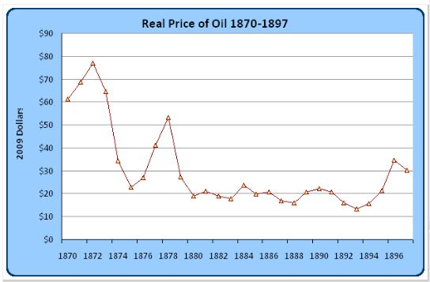

Graph 1: Michael Rizzo, graph of changes in the real price of oil, 1870–1897, Wicked Slashers of Cost, 2009.
© Michael Rizzo. Used with permission

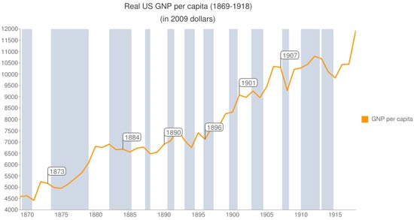

Graph 2: Chart depicting the growth in real GNP from 1869 to 1918.
Public domain. Chart created by Equilibrium007 July 24, 2010. Wikimedia Commons: http://commons.wikimedia.org/wiki/File:US-GNP-per-capita-1869-1918.png.

Supporting Question 2
Featured Source | Source B: Senator Leland Stanford, an interview with Stanford on his thoughts about the nature of capital, New York Tribune (excerpt), May 4, 1887

…LABOR IS THE CREATOR OF CAPITAL, And capital is in the nature of a stored up force. It is like the balance wheel of an engine, which has no motion that has not been imparted to it, but is a reservoir of force which will perpetuate the motion of the machinery after the propelling power has ceased. A man takes a few thousand dollars of capital, builds a workshop, buys raw material advantageously, and engages a hundred workmen to manufacture boots and shoes. This is the foundation of enterprise. The employer of labor is a benefactor. The great majority of mankind do not originate employments for themselves. They either have not the disposition, or the ability to so originate and direct their own employment. Whatever may the fault, it is truth that the majority of mankind are employed by the minority.
Public domain. http://dynamics.org/Altenberg/ARCHIVES/STANFORD/LELAND_STANFORD/Stanford_Cooperation_of_labor.1887.pdf.

Supporting Question 2
Featured Source | Source C: Andrew Carnegie, explanation about how to solve problems of wealth inequality in the late 19th century, “Wealth,” North American Review (excerpts), June, 1889

NOTE: The following text is taken from an 1889 article written by the industrialist and philanthropist Andrew Carnegie in which he describes an approach to dealing with wealth inequality. In his proposed system, wealthy individuals would give away their surplus wealth, or what they do not need, in order to help those less fortunate. Carnegie had become famous for donations to local communities, including library buildings and church organs. In this excerpt, Carnegie justifies the system that supports the existing wealth inequality.
The problem of our age is the proper administration of wealth, so that the ties of brotherhood may still bind together the rich and poor in harmonious relationship. The conditions of human life have not only been changed, but revolutionized, within the past few hundred years. In former days there was little difference between the dwelling, dress, food, and environment of the chief and those of his retainers. The Indians are to-day where civilized man then was. When visiting the Sioux, I was led to the wigwam of the chief. It was just like the others in external appearance, and even within the difference was trifling between it and those of the poorest of his braves. The contrast between the palace of the millionaire and the cottage of the laborer with us to-day measures the change which has come with civilization.
This change, however, is not to be deplored, but welcomed as highly beneficial. It is well, nay, essential for the progress of the race, that the houses of some should be homes for all that is highest and best in literature and the arts, and for all the refinements of civilization, rather than that none should be so….
Formerly articles were manufactured at the domestic hearth or in small shops which formed part of the household. The master and his apprentices worked side by side, the latter living with the master, and therefore subject to the same conditions. When these apprentices rose to be masters, there was little or no change in their mode of life, and they, in turn, educated in the same routine succeeding apprentices. There was, substantially social equality, and even political equality, for those engaged in industrial pursuits had then little or no political voice in the State.
But the inevitable result of such a mode of manufacture was crude articles at high prices. To-day the world obtains commodities of excellent quality at prices which even the generation preceding this would have deemed incredible. In the commercial world similar causes have produced similar results, and the race is benefited thereby. The poor enjoy what the rich could not before afford. What were the luxuries have become the necessaries of life. The laborer has now more comforts than the landlord had a few generations ago. The farmer has more luxuries than the landlord had, and is more richly clad and better housed. The landlord has books and pictures rarer, and appointments more artistic, than the King could then obtain….
We accept and welcome therefore, as conditions to which we must accommodate ourselves, great inequality of environment, the concentration of business, industrial and commercial, in the hands of a few, and the law of competition between these, as being not only beneficial, but essential for the future progress of the race.
Public domain. Source: http://www.let.rug.nl/usa/documents/1876-1900/andrew-carnegie-wealth-june-1889.php.

Supporting Question 2
Featured Source | Source D: Westchester Daily Telegram, cartoon depicting Andrew Carnegie’s efforts as a philanthropist, March 26, 1913

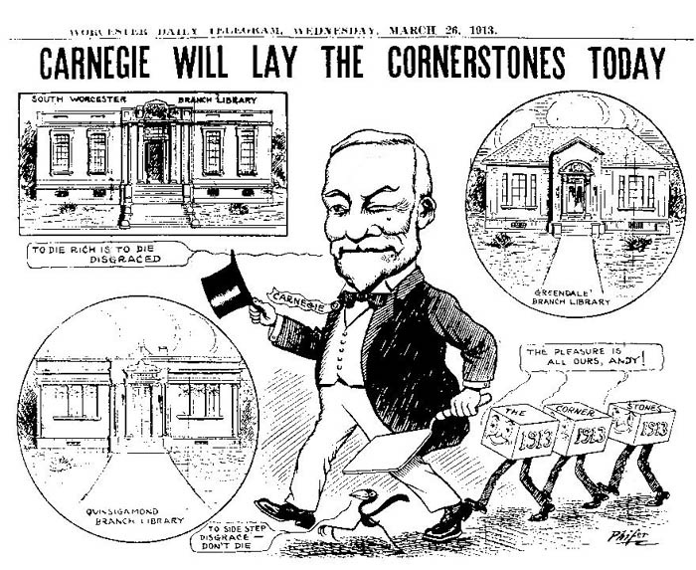
Public domain.

Supporting Question 3
Featured Source | Source A: W. A. Rogers, The Forty T-----, [Thieves]: Baba Jonathon: I don't like your looks, Mr. Merchant, you had better move on, illustration, Harper's Weekly, 17 March 1888

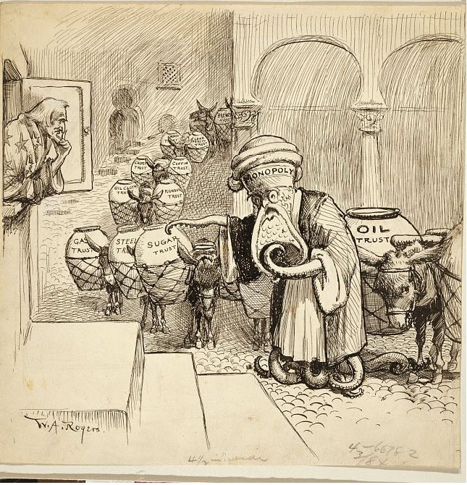
Public domain. Library of Congress. Source: http://www.loc.gov/pictures/resource/cph.3g12535/.

Supporting Question 3
Featured Source | Source B: Author unknown, an essay offering a counter argument to Andrew Carnegie’s theory about wealth, “Workingman’s Prayer for the Masses” (excerpts),1894

NOTE: In his essay “Wealth,” published in the North American Review in 1889, industrialist Andrew Carnegie argued that individual capitalists were bound by duty to play a broader cultural and social role and thus improve the world. (The essay later became famous under the title “The Gospel of Wealth.”) But not everyone agreed with Carnegie’s perspective. This 1894 “prayer” by “A Workman” (an anonymous contributor to the National Labor Tribune) was a sarcastic critique of Carnegie’s paternalism and philanthropy.

Oh, Almighty Andrew Philanthropist Library Carnegie, who art in America when not in Europe spending the money of your slaves and serfs, thou art a good father to the people of Pittsburgh, Homestead and Beaver Falls. We bow before thee in humble obedience of slavery….We have no desire but to serve thee. If you sayest black was white we believe you, and are willing, with the assistance of…the Pinkerton’s agency, to knock the stuffin[g] out of anyone who thinks different, or to shoot down and imprison serfs who dare say you have been unjust in reducing the wages of your slaves, who call themselves citizens of the land of the free and the home of the brave….
Oh, lord and master, we love thee because you and other great masters of slaves favor combines and trusts to enslave and make paupers of us all. We love thee though our children are clothed in rags. We love thee though our wives…are so scantily dressed and look so shabby. But, oh master, thou hast given us one great enjoyment which man has never dreamed of before—a free church organ, so that we can take our shabby families to church to hear your great organ pour forth its melodious strains….
Oh, master, we thank thee for all the free gifts you have given the public at the expense of your slaves….Oh, master, we need no protection, we need no liberty so long as we are under thy care. So we command ourselves to thy mercy and forevermore sing thy praise.
Amen!
Public domain. Letter from “A Workman” to the National Labor Tribune. Reprinted in The Coming Nation, 10 February 1894. http://historymatters.gmu.edu/d/5007/.

Supporting Question 3
Featured Source | Source C: Author unknown, letter to the editor critical of the power of industrialists, “Evolution of the Robber Baron,” New York Times, December 7, 1902

Evolution of The Robber Baron
To the Editor of The New York Times:
With your kind permission I would like to say a few words upon a subject which I will call the “Evolution of the Robber Baron.”
It is well known that in the early Middle Ages, or rather during the Dark Ages, the original robber barons, the feudal lords of certain small German principalities, made periodical raids upon their vassal subjects, despoiling them of the hard-earned accumulations of years and otherwise appropriating their substance either by right of eminent domain or by main force exercised by the strong against the weak. At a later period, during the fourteenth and fifteenth centuries, the same process was carried on by both English and German rulers against their Jewish subjects, who were then considered legitimate prey whenever an impoverished exchequer had to be replenished. “My Jews,” as these rulers used to call them, whenever they had accumulated enough wealth to yield a rich harvest, were made to disgorge in short order.
Such were the conditions five centuries ago, and now in the twentieth century come the modern robber baron, an evolution of the original article, in the shape of the railroad financier: he swoops down from his office like his ancient prototype from his castle, and by obtaining control of this or that railroad property, after he has assured himself that it is on a sure paying basis, takes everything in sight be means of the Holding Company, or the Securities Company, which he and his robber baron friends arrange to organize within the law, to the detriment of the surprised and unwilling minority owners of the property. Take the Manhattan Hallway Company, for instance. It’s owners (general stockholders, have for years been carrying this magnificent property at a nominal income, hoping the time would come when they would be repaid for their patience; well, the time has come, or is about to come, but not for them. True they are to receive a better income than heretofore, but the sponsers of the Inter-urban Company will see to it that they don’t get too much now that much better earnings are in prospect for the property, and they have also seen to it that they get all the balance over 7 per cent, for all time to come.
Now, where is the difference between the robber barons of old and these modern railroad financiers? None whatever, I take it, except that the former helped themselves at will, and the latter are helping themselves within the protection of laws made to legalize the robbery.
L.B.
New York, Dec. 1, 1902

Public domain. The New York Times Company, December 7, 1902, Page 33.

Supporting Question 3
Featured Source | Source D: Theodore Roosevelt, special message to Congress (excerpts), May 4, 1906

To the Senate and House of Representatives:
I transmit herewith a report by the Commissioner of the Bureau of Corporations in the Department of Commerce and Labor on the subject of transportation and freight rates in connection with the oil industry. The investigation, the results of part of which are summarized in this report, was undertaken in accordance with House Resolution 499, passed February 15, 1905, but for the reasons given in the report it has been more general and extensive than was called for in the resolution itself….
The report shows that the Standard Oil Company has benefited enormously up almost to the present moment by secret rates, many of these secret rates being clearly unlawful. This benefit amounts to at least three-quarters of a million a year. This three-quarters of a million represents the profit that the Standard Oil Company obtains at the expense of the railroads; but of course the ultimate result is that it obtains a much larger profit at the expense of the public….
But in addition to these secret rates the Standard Oil profits immensely by open rates, which are so arranged as to give it an overwhelming advantage over its independent competitors. The refusal of the railroads in certain cases to prorate produces analogous effects. Thus in New England the refusal of certain railway systems to prorate has resulted in keeping the Standard Oil in absolute monopolistic control of the field, enabling it to charge from three to four hundred thousand dollars a year more to the consumers of oil in New England than they would have had to pay had the price paid been that obtaining in the competitive fields. This is a characteristic example of the numerous evils which are inevitable under a system in which the big shipper and the railroad are left free to crush out all individual initiative and all power of independent action because of the absence of adequate and thorough-going governmental control. Exactly similar conditions obtain in a large part of the West and Southwest. This particular instance exemplifies the fact that the granting to the Government of the power to substitute a proper for an improper rate is in very many instances the only effective way in which to prevent improper discriminations in rates.
The argument is sometimes advanced against conferring upon some governmental body the power of supervision and control over interstate commerce, that to do so tends to weaken individual initiative. Investigations such as this conclusively disprove any such allegation. On the contrary, the proper play for individual initiative can only be secured by such governmental supervision as will curb those monopolies which crush out all individual initiative. The railroad itself can not without such Government aid protect the interests of its own stockholders as against one of these great corporations loosely known as trusts….
Though not bearing upon the question of railroad rates, there are two measures, consideration of which is imperatively suggested by the submission of this report. The Standard Oil Company has, largely by unfair or unlawful methods, crushed out home competition. It is highly desirable that an element of competition should be introduced by the passage of some such law as that which has already passed the House.
Public domain. Theodore Roosevelt: "Special Message," May 4, 1906. Online by Gerhard Peters and John T. Woolley, The American Presidency Project. http://www.presidency.ucsb.edu/ws/?pid=69667.

