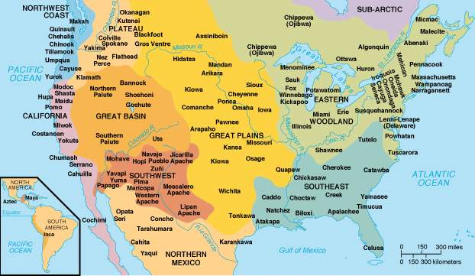
Period 1 Overview: 1491-1607
Overview Prior to the arrival of Christopher Columbus and other Europeans, the North American continent was home to diverse societies controlled by Native Americans. The first of these peoples arrived in the Americas at least 10,000 years ago, most likely by migrating across a land bridge called Beringia. These societies developed a wide variety of social, political, and economic structures based on interactions with the environment and each other. After 1492, the contact among the peoples of Europe, the Americas, and West Africa increasingly transformed the world, creating what is known as the “Columbian Exchange.” There were many positive and negative effects of this trans-Atlantic exchange, as well as worldview challenges. By 1607, the first permanent English settlement was established at Jamestown, Virginia, marking the beginning stages of a new nation.
Beginning = Pre­‐Columbian America, pre­‐Columbian Exchange, Native American life without European explorers/colonizers running around.

What do I need to know?

1. Native American life pre and post European contact.

a. Examples: Maize production, nomadic hunter/gathering, Pueblo, Northeast & Atlantic tribes like Algonquin, Powhatan, & Iroquois developed permanent villages, THEN horses, guns, disease, Columbian Exchange
2. European Patterns of Conquest/Colonization:

a. Spain: New World a source of precious metal and religious conversion, Native Americans = people to be converted to Christianity…settled central and South America, Caribbean
b. England: New World a source of precious metal and raw material– settler colonies – Native Americans = savages…settled Atlantic seacoast
c. France: New World = source for raw materials like fur – Natives = friends and trading partners….settled Canada and Ohio River Valley
3. Interactions between Natives and European people.

a. Examples: Encomienda System, Mestizos, Fur Traders, Columbian Exchange, Smallpox

End of Period 1 = Founding of Jamestown in 1607. First Permanent English colony in theNew World.
Period Perspectives Contact between Europeans and the natives of America touched off a trans-Atlantic trade in animals, plants, and germs known as the Columbian Exchange. This trade altered the way people around the globe lived and thought. Within a hundred years, Spanish and Portuguese explorers and settlers developed colonies using natives and enslaved Africans for labor in agriculture and mining precious metals. Natives and Africans resisted oppression by maintaining elements of their cultures. The Spanish and the Portuguese were quickly followed to the Americas by the French and the Dutch, and later by the English.
Alternate Viewpoint Until the mid-20th century, most historians viewed Columbus and European explorers and settlers as great adventurers who founded colonies that developed into modern democracies. However, in recent years, historians have highlighted the vibrant and diverse native cultures that existed in the Americas before the arrival of Columbus, and how European diseases and violence destroyed so much of these cultures. The native population declined by 90 percent after the arrival of Europeans. To demonstrate this greater emphasis on native culture, historians often begin this period in 1491 rather than 1492.
Key Terms: Incas, Aztecs, Columbian Exchange, Treaty of Tordesillas, encomienda, mestizo, conquistadores, Popes Rebellion, Black Legend

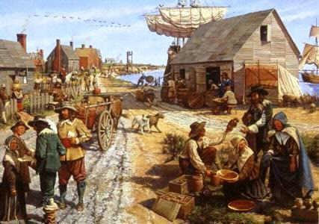
Period 2 Overview: 1607-1754
Overview Beginning in 1607, England, France, and Spain all established settlements in North America. Differences in imperial goals, cultures, and North American environments led these nations to develop diverse patterns of colonization. The growth of slavery, triangular trade, Enlightenment ideals and Protestant evangelism helped shape English colonial society and the economy. The French and the Spanish traded and intermarried with Native Americans, and attempted religious conversions. As a result of these differences and growing conflicts between Europeans and Native Americans, distinctive colonial and native societies emerged, leading to a struggle to control resources and the beginning of the Seven Years War.

BEGINNING = Founding of Jamestown settlement in Virginia, 1607.

What do I need to know?

1. Success and Failures of European colonization, (interaction between Natives and European colonists, Europeans and Africans, Work Systems, etc.)
a. Examples: Pueblo Revolt, King Phillip’s War, Slave Trade, Middle Passage, Stono Rebellion, Bacon’s Rebellion
2. How did England become the dominant colonial power? What were the regional DIFFERENCES among English colonies!?
a. Examples: New England Puritans, City Upon A Hill, , Middle Colonies Merchant class, Quakers, Chesapeake Tobacco, Southern Colonies, Cash Crops, slavery
3. Effects of major social movements Enlightenment and Great Awakening on colonial American identity
a. Examples: John Locke “Natural Rights”, Benjamin Franklin, Jonathan Edwards “Sinners in the Hands of an Angry God”, George Whitefield, Reason

END = French & Indian War 1754 between England and France for control of the Americas and the Ohio River Valley (George Washington starts it)

Period Perspectives From the establishment of the first permanent English settlement in North America to the start of a decisive war for European control of the continent, the colonies evolved. At first, they struggled for survival, but they became a society of permanent farms, plantations, towns, and cities. European settlers brought various cultures, economic plans, and ideas for governing to the Americas. In particular, they all sought to dominate the Native Americans. The British took pride in their tradition of free farmers working the land. The various colonies developed regional or sectional differences based on many influences including geography, climate, natural resources, economic motivations, and religious backgrounds of their settlers. They largely viewed the American Indian as an obstacle to colonial growth. With their emphasis on agriculture came a demand for labor, and this led to a growing dependence on slavery and the Atlantic slave trade to power the economy. The start of the Seven Years' War signified the maturity of the British colonies and the influence of European conflicts in the power struggle for control in North America.
Alternate View Historians disagree on what date best marks the end of the colonial era. Some identify the conclusion of the Seven Years' War in 1763 or the start of the American Revolution in 1775 or the signing of a peace treaty in 1783. Historians who focus on cultural rather than political and military events might choose other dates for both the start and end of the period that emphasize the role of non-English residents, such as the Scotch-Irish, Germans, and enslaved Africans, in the colonies.
Key Terms: Protestant Reformation, Spanish Armada, primogeniture, joint-stock company, Jamestown, Anglo-Powhatan Wars, Houses of Burgesses, Acts of Toleration, Iroquois Confederacy, Mayflower Compact, Fundamental Orders of Connecticut, Dominion of New England, King Philip’s War, Glorious Revolution, Navigation Laws, Salutary Neglect, Indentured servants, headright system, Bacon’s Rebellion, middle passage, slave codes, Half-Way Covenant, Salem Witch Trials, Paxton Boys, triangular trade, Molasses Act, Great Awakening, William Pitt, Albany Plan, Proclamation of 1763, Pontiac’s Rebellion

