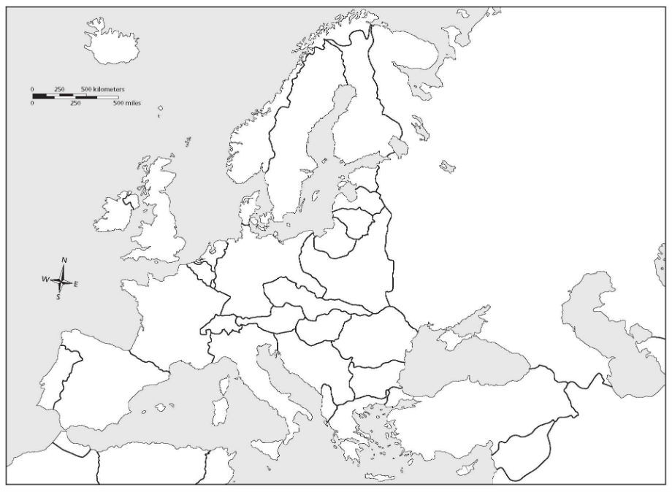
World War II Map and Timeline Activity
June , 1944
May-June , 1940

Directions: For each event, click on the link & read. Then, 1) Write the name of the event and 2) a two sentence summary in the boxes on the map.
September , 1939
BLITZKREIG – Hitler invaded Poland starting World War II. Although Britain and France promised to protect Poland, the country falls to Germany in a matter of weeks.

December , 1944
June, 1941
July-September, 1940

© 2017 Bell, Book and Camera Productions
June , 1940
May, 1945
January , 1945

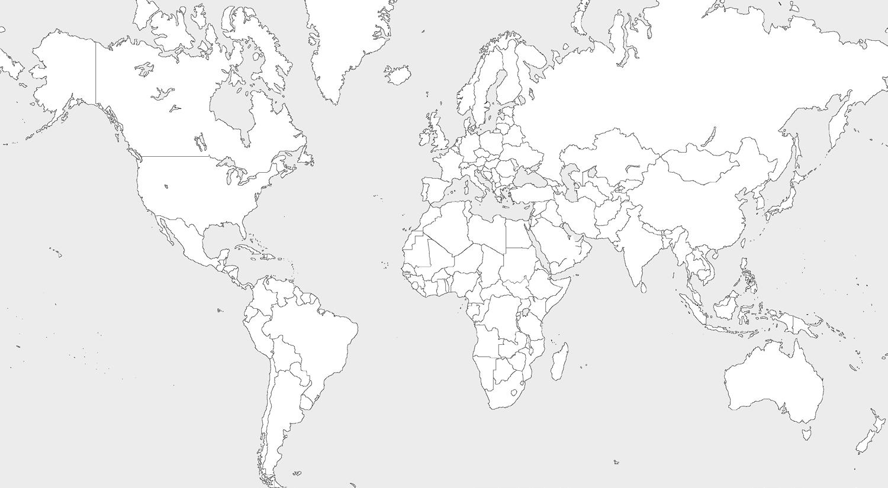
July , 1945
September , 1931
August, 1945

July , 1937

December , 1941
May , 1942

© 2017 Bell, Book and Camera Productions
June , 1942

